# **Phase 3 – Operational Configuration (Custom Objects & Relationships)**

### **1. Introduction**

This phase sets up **core operational objects, fields, relationships, and layouts** for the Punjab Flood Relief CRM. It ensures the system is ready to manage **Donors, Donations, Volunteers, Relief Requests, and Distributions**, along with reporting and mobile access.

### **2. Create Custom Objects**

**Objects to create:**

* Donor
* Donation
* Volunteer
* Relief Request
* Distribution

**Example: Create Donation object**  
 **Navigate:** Setup → Object Manager → Create → Custom Object

* Fill details:
  + Label: Donation
  + Plural Label: Donations
  + API Name: Donation__c (auto)
* Check ✅:
  + Allow Reports
  + Allow Activities
  + Track Field History (optional)
  + Launch New Tab Wizard after saving
* Save.
* Tab Wizard → Style: pick an icon (💰 or 📦), Tab Visibility = Default On  
  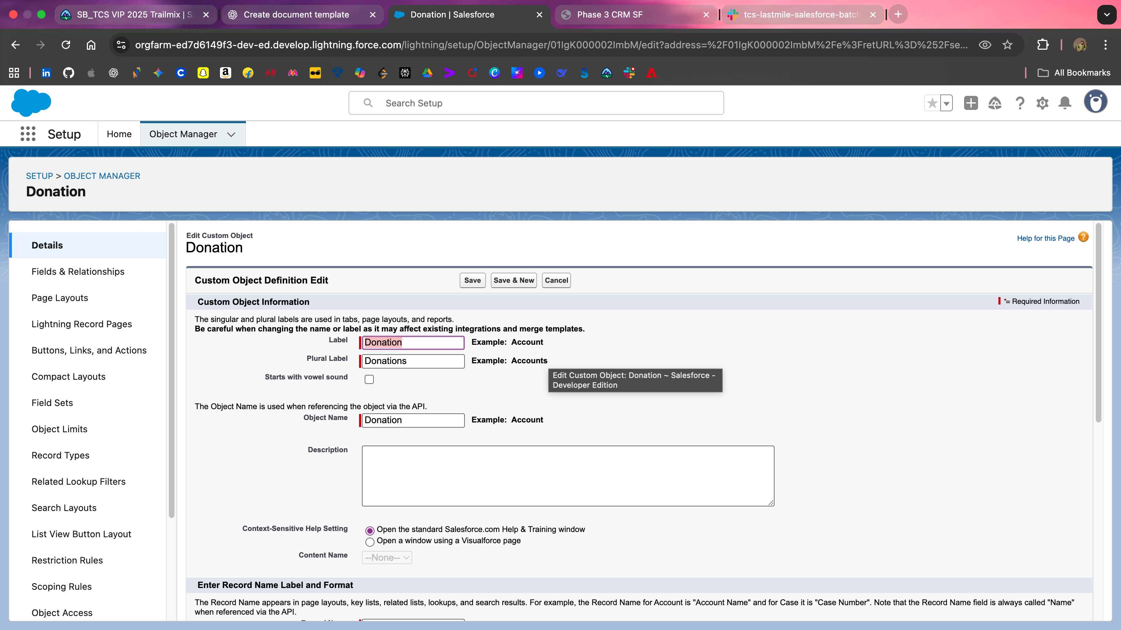

✅ Repeat same steps for **Donor, Volunteer, Relief Request, Distribution**

### **3. Module 2: Add Custom Fields**

**Donor__c**

* Contact Number (Phone)
* Email (Email)
* Donor Type (Picklist: Individual, Corporate, NGO)  
  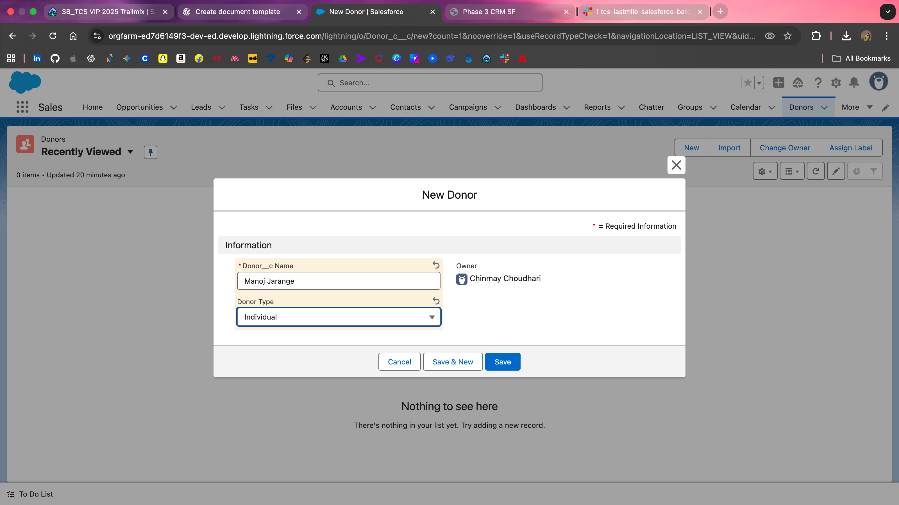

**Donation__c**

* Donation Type (Picklist: Food, Clothes, Money, Medicines)
* Donation Amount (Currency)
* Status (Picklist: Pledged, Received, Distributed)
* Lookup → Donor__c  
  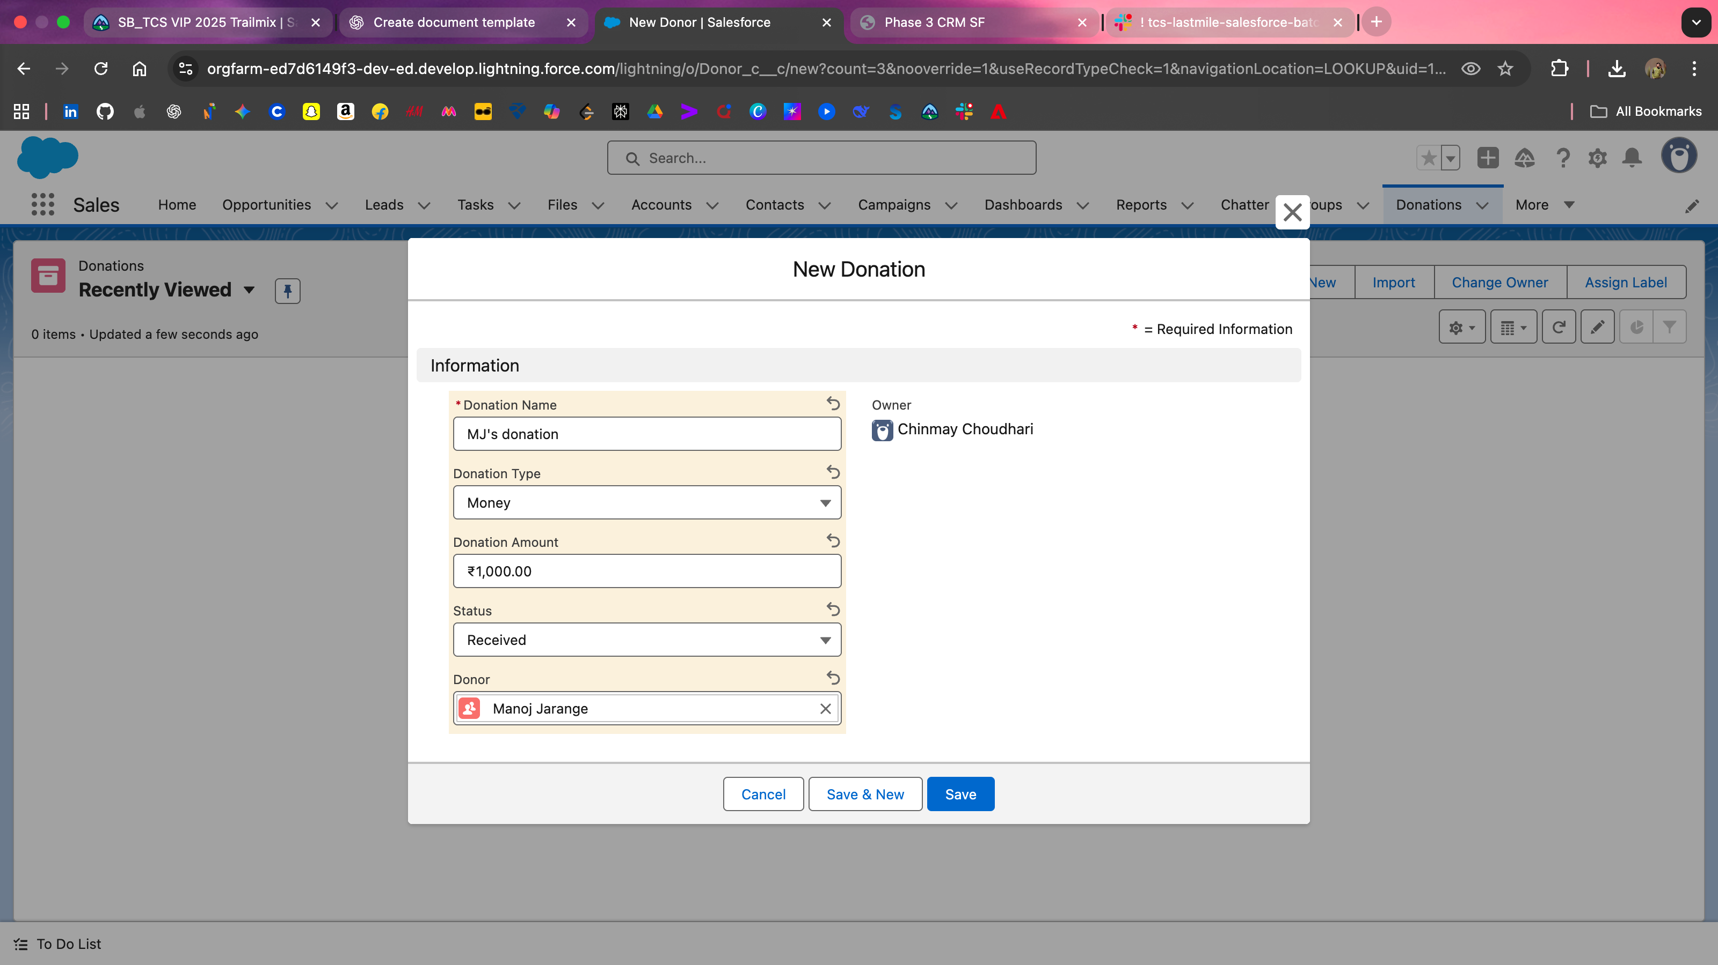

**Volunteer__c**

* Skillset (Picklist: Medical, Logistics, Transport, General)
* Availability (Checkbox)
* Location (Text)  
  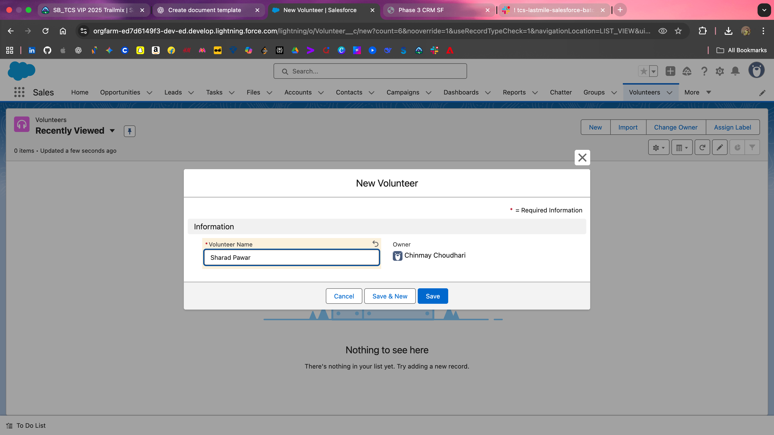

**Relief_Request__c**

* Disaster Type (Picklist: Flood, Earthquake, Fire, Other)
* Urgency (Picklist: Low, Medium, High)
* Needed Items (Text Area)
* Status (Picklist: Open, In Progress, Fulfilled)  
  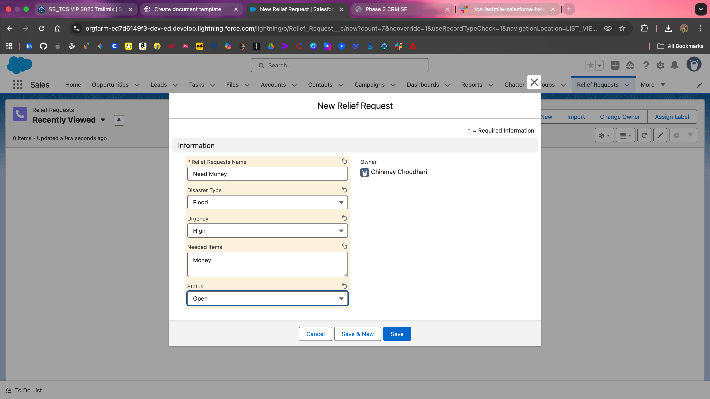

**Distribution__c**

* Lookup → Donation__c
* Lookup → Volunteer__c
* Lookup → Relief_Request__c
* Status (Picklist: Assigned, Delivered, Pending)  
  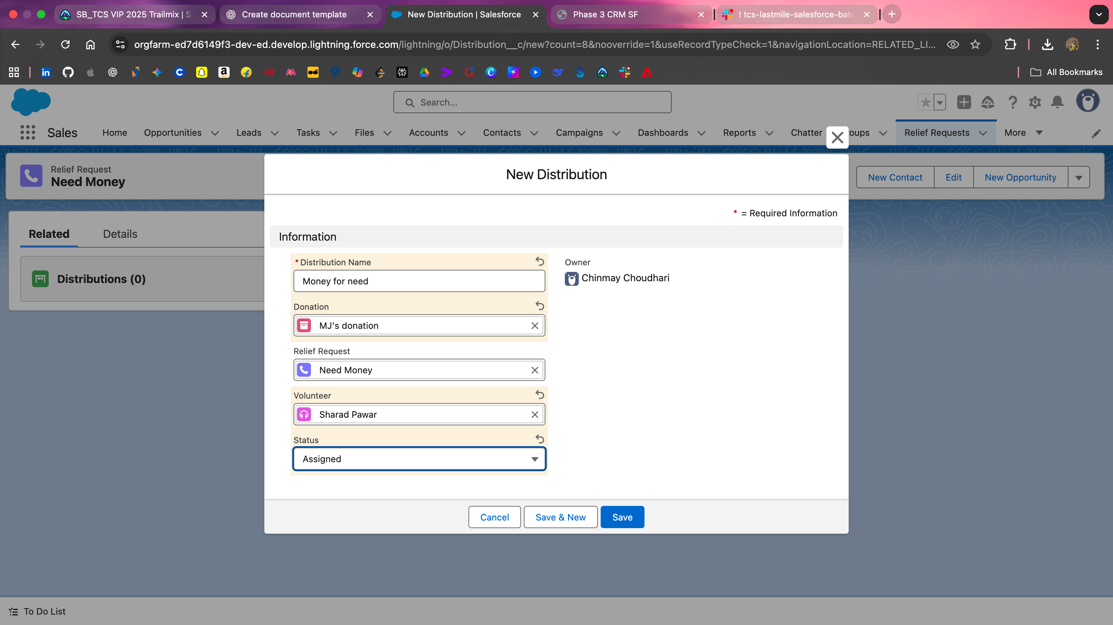

### **4.Record Types, Page Layouts, Compact Layouts**

**Record Types:**

* Example: Relief Request → Flood Request vs Earthquake Request
* Purpose: Different picklist defaults for different users

**Page Layouts:**

* Donation Layout → Donor Manager sees **Amount + Status** at top
* Volunteer Layout → Minimal fields for volunteers

**Compact Layouts (for mobile):**

* Donation: [Donation Type, Amount, Status]
* Volunteer: [Name, Skillset, Availability]

**Screenshot placeholders:**

* [Insert Record Type setup screenshot here]
* [Insert Page Layout screenshot here]
* [Insert Compact Layout screenshot here]

### **5.Define Relationships**

**Relationships:**

* **Donor → Donation (1:M)** → Add Lookup(Donor) field on Donation
* **Relief Request ↔ Donation (M:M)** → Use **Distribution__c** as junction object
* **Volunteer ↔ Distribution (M:M)** → Distribution__c lookup to Volunteer__c

**Distribution__c** connects **Donations, Requests, and Volunteers**

### **6. Schema Builder (Visualization)**

**Navigate:** Setup → Quick Find → Schema Builder

* Select objects: **Donor, Donation, Volunteer, Relief Request, Distribution**
* Drag objects on canvas
* Visualize:
  + Donor → Donation (1:M)
  + Donation ↔ Relief Request (via Distribution)
  + Volunteer ↔ Distribution (M:M)

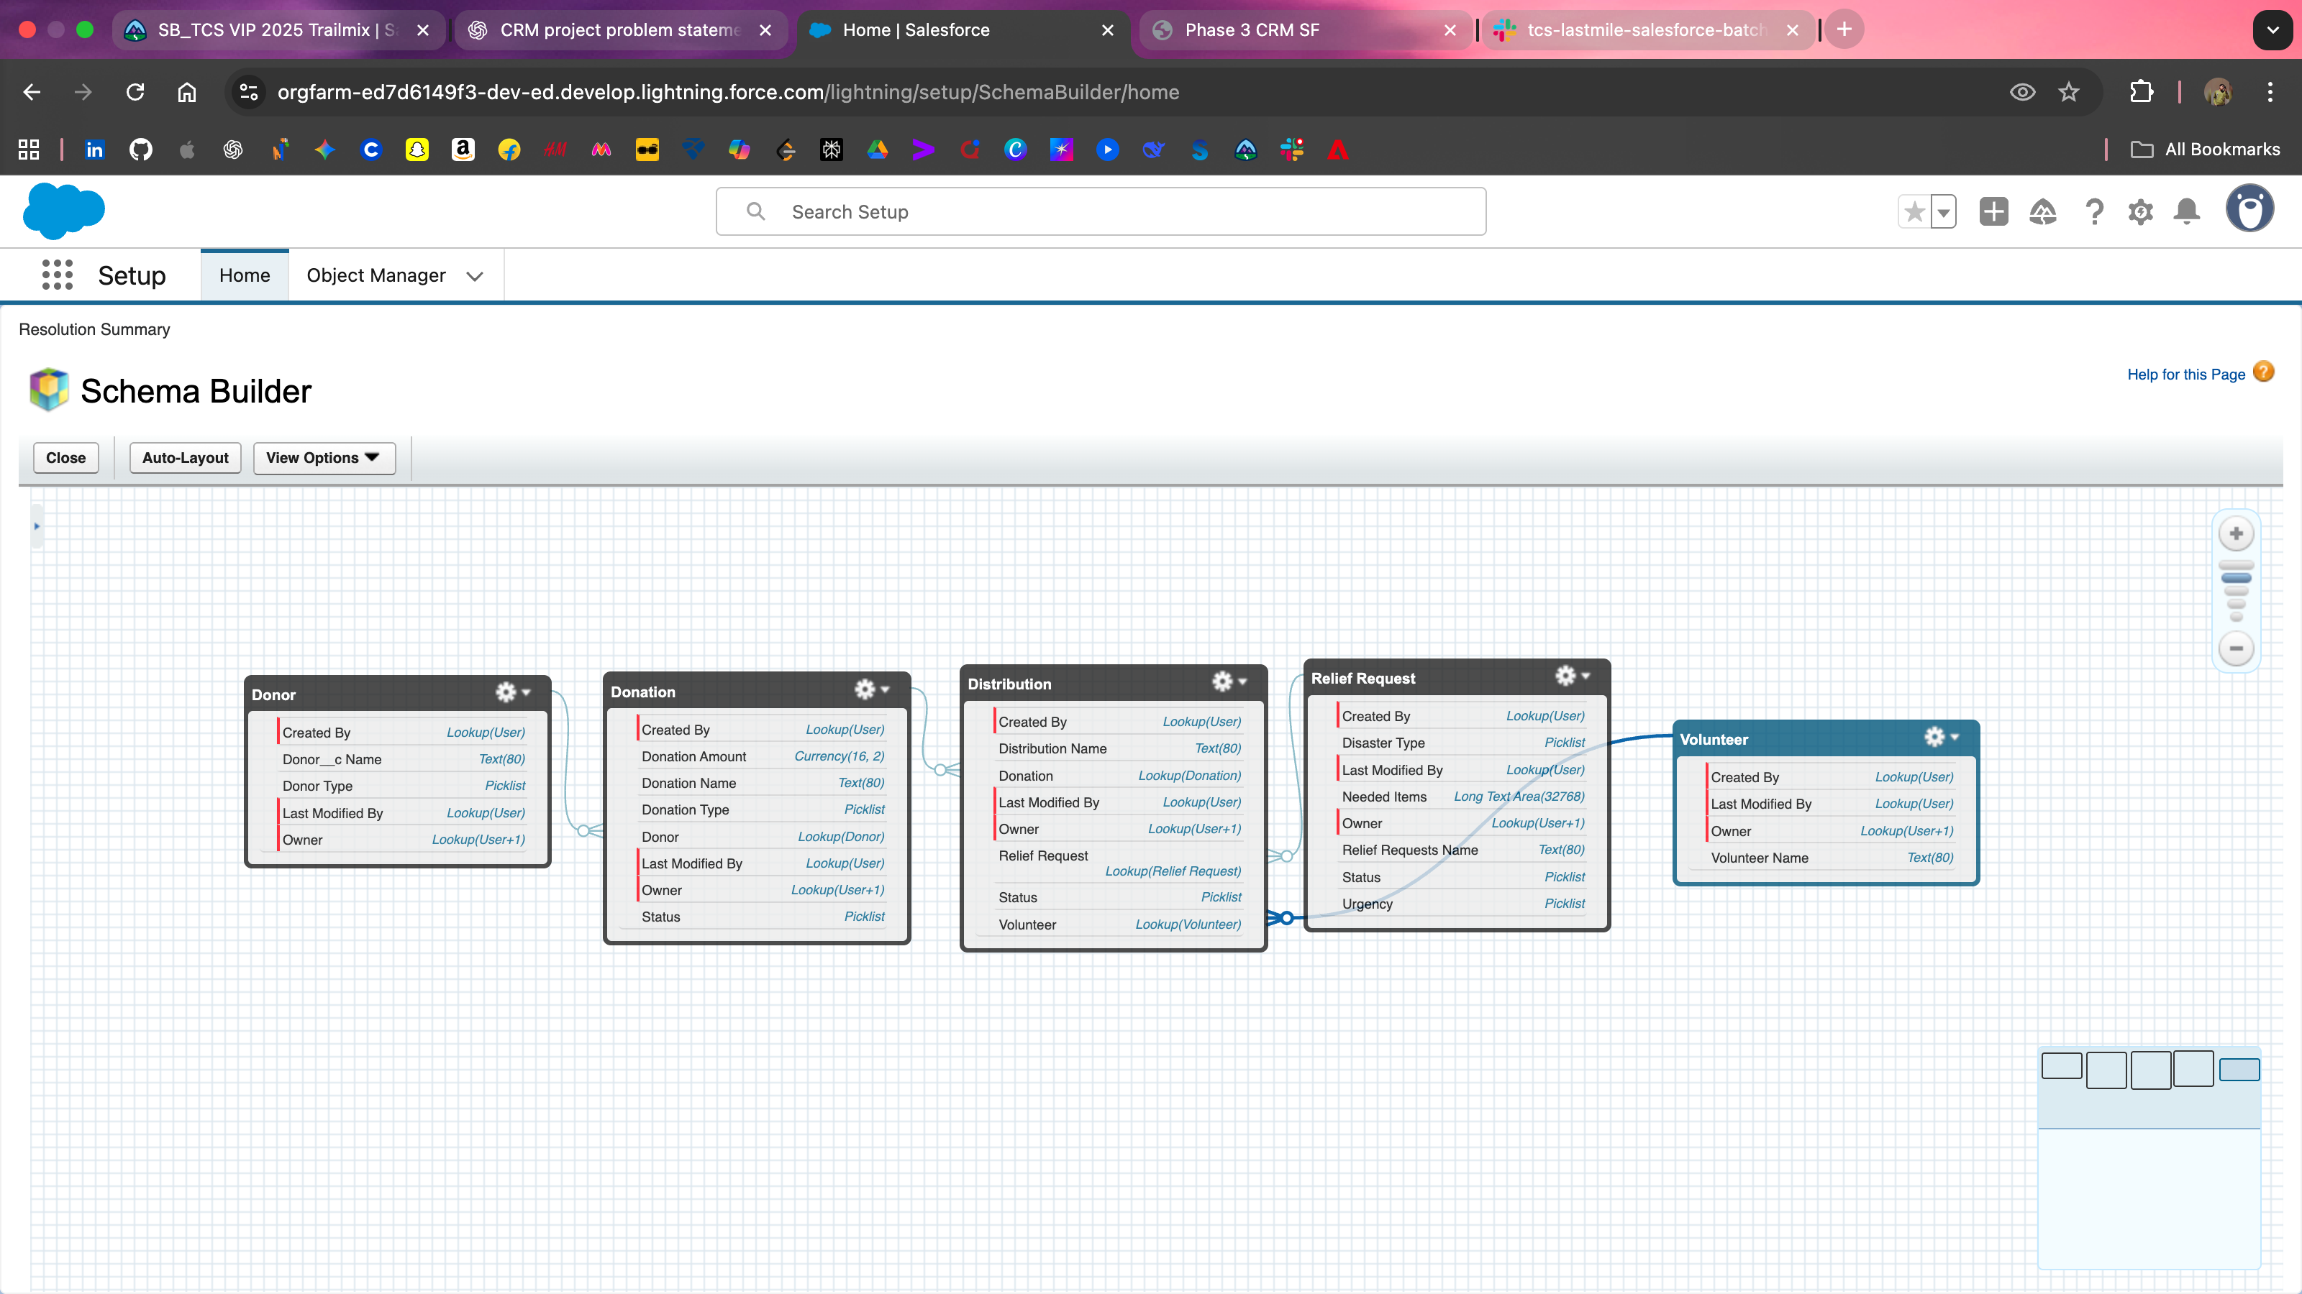

### **7. Phase 3 Conclusion**

Phase 3 ensures the Salesforce Org is fully **operational for managing Donors, Donations, Volunteers, Relief Requests, and Distributions**. With **custom objects, fields, layouts, relationships, and Schema Builder visualization**, your org is ready for **data entry, reporting, and demo presentations**.